Building a Spacecraft

Before you can journey to the planet and complete your tasks you must build and launch a spacecraft.

A) Cut the bendy part of the straw off.

B) Thread the straight part of the straw onto a long piece of wool.

C) Tie the wool to two chairs, stretching it across them.

D) Blow up a balloon (not too big).

E) Do not tie the balloon! Hold it closed with a clothespeg.

F) Use sticky tape to stick the balloon to the underside of the straw.

G) Take the peg off the balloon to fire the rocket.

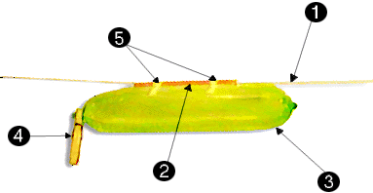
Science Experiments

Whilst you are on the planet you must complete 3 science experiments. Dr Boulton will help you with the experiments.

1) Does the planet’s air expand when it gets hot?

2) Does a fire cause part of the air to be used up?

3) Can static electricity be used to attract light objects?

Investigating Alien Life

The European Space Agency believes that this planet is home to alien life forms. Try to find six examples, completing a box (on the following pages) for each species. Since you have discovered these life forms you can choose what to call them. Do not attempt to touch or move the life forms as they may be dangerous! If you are unsure what to do Dr Panther will help you.

Name of Life Form:

Number of legs:

Colour of skin:

Number of arms:

Number of eyes:

Any other observations/drawing:

Name of Life Form:

Number of legs:

Colour of skin:

Number of arms:

Number of eyes:

Any other observations/drawing:

Name of Life Form:

Number of legs:

Colour of skin:

Number of arms:

Number of eyes:

Any other observations/drawing:

Name of Life Form:

Number of legs:

Colour of skin:

Number of arms:

Number of eyes:

Any other observations/drawing:

Name of Life Form:

Number of legs:

Colour of skin:

Number of arms:

Number of eyes:

Any other observations/drawing:

Name of Life Form:

Number of legs:

Colour of skin:

Number of arms:

Number of eyes:

Any other observations/drawing:
Making a Space Hovercraft

When you have left the planet the European Space Agency would like to continue to explore the planet through a robot. Make a simple Hovercraft Rover. Dr Thumper will help you with this task.

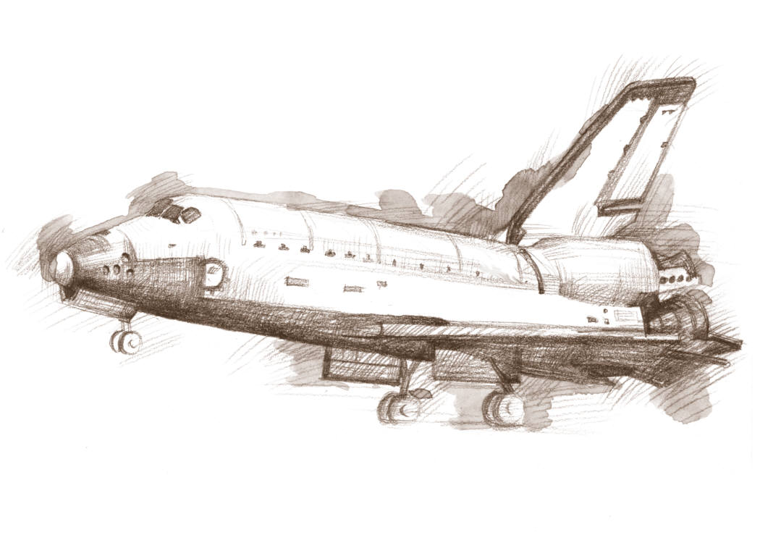

Collecting Fuel Pods

In order to safely return to Earth you will need more fuel for your rocket. Locate and collect 10 fuel pods, hidden on the planet’s surface. Dr Hedgehog will help you will this task.

